Omicron: Mutations Found in the Spike Protein and How they Affect the Variant.
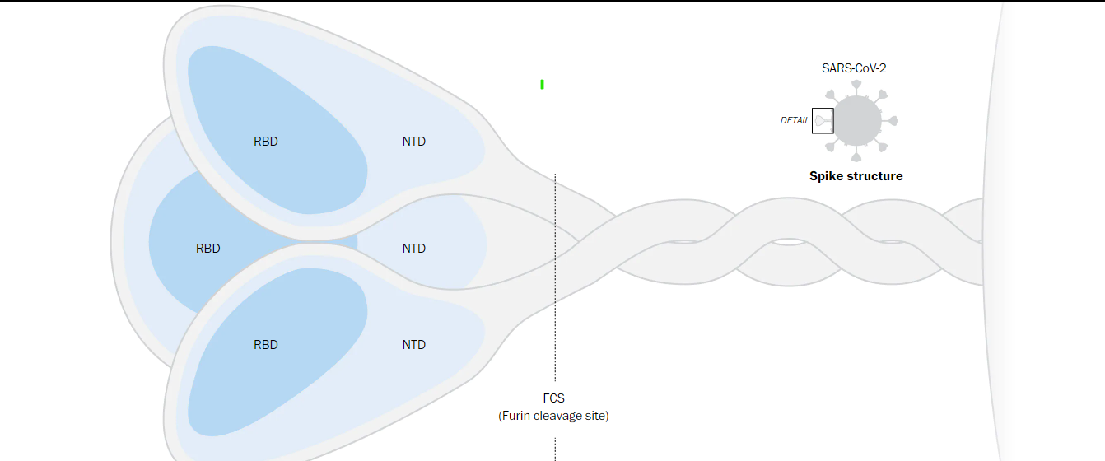
Figure 1: I want this photo to be slightly larger.
https://www.washingtonpost.com/health/2021/12/16/omicron-variant-mutations-covid/
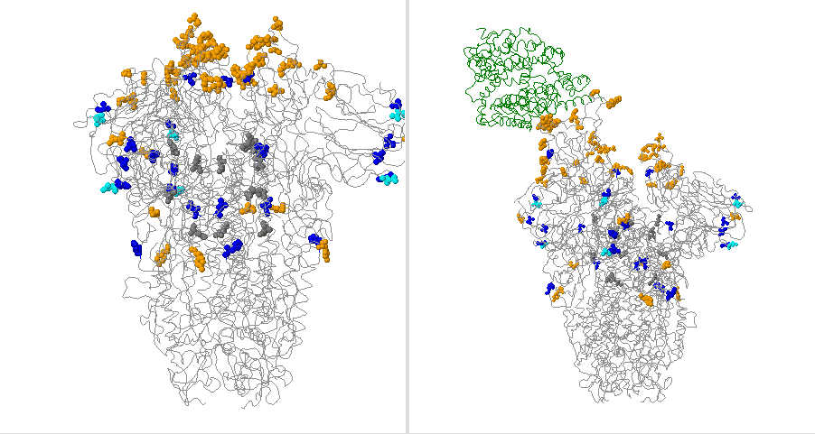
Figure 2: A protein model for the 21K Omicron variant.
https://covariants.org/variants/21K.Omicron

Medical Article
By Svetlana Backhaus, STEM Columnist, 01/13/2022
What do the dangers of the Omicron variant stem from? This article explores this topic, along with the most obvious and severe mutations found on this coronavirus variant.
Genetic mutations in viruses occur when the amino acid sequence of proteins changes. These genetic mutations can have very minute effects, resulting in silent mutations that do not change the amino acid sequence of a protein or in absolutely devastating effects due to insertion or deletion of amino acids. The Omicron variant is suspected to have 32 mutations on the spike protein and about 18 mutations found elsewhere in the virus. These mutations are responsible for the very unique characteristics of this virus.
First, we need a small review of how mutations occur in proteins to aid in the understanding of the following data. There are two types of DNA codon mutations that then lead to errors in mRNA codon sequences, tRNA codon arrangement, and finally an incorrect ordering of amino acids. These two types of mutations are point mutations and frameshift mutations. The Omicron variant exhibits both of these mutations, as insertion and deletion(both frameshift mutations) and substitution and silent mutations(both being point mutations) are found all over the spike protein. Spike proteins latch onto the cell membrane of healthy cells, which then allows them entry into the cell. Mutations found on the spike protein manage how the virus reproduces itself, its immunity to antibodies and other forms of immune defense, and how the virus is detected to testing.
Now let us quickly glance over a few of the most prominent mutations found along the spike protein of the Omicron variant. The bullets below outline these mutations and describe their purpose.

- S gene dropout or S gene target failure: this mutation allows for scientists to detect the Omicron variant while conducting PCR testing.
- About 15 mutations are found on the receptor binding domain(see figure 1), making the connection between the cell receptor and the spike protein stronger. This directly connects to the high transmissibility of the Omicron variant. One of the most important mutations in this area is the N501Y, which helps the virus hold onto the cell receptors more tightly.
- Studies have shown that antibodies—both from vaccines and previous infection—attack the N-terminal domain to rid the cells of the virus. The total mutations occurring in this section of the spike protein are 4 amino acid substitutions, 6 deletions in three locations, and three insertions in one segment of the N-terminal domain. These enormous mutations on the N-terminal domain can lead to antibodies binding to the coronavirus less efficiently, and a higher possibility of the vaccinated and previously infected being reinfected by this variant. The only hope for Omicron safety and prevention is to overload the variant with antibodies, which can be done with boosters.
- A mutation on the furin cleavage site in the Omicron variant is an unfortunate mutation for this virus, as it is not as strong as the mutation found in the Delta variant in the same location. However, Omicron does have two mutations unique to this variant found close by, but the early stages of studies cannot determine the consequences of the combination of these three mutations. The furin cleavage site

A look to the future:
What do these mutations occurring in the spike protein mean for transmissibility and risk of severe infection? Well, no one is quite sure yet, as Omicron is a very new variant and extensive laboratory tests have not yet been conducted. But we can make predictions based on the evidence found in the mutations on the spike protein of the Omicron variant.
Firstly, is the incredibly high transmissibility rate of this variant. As of the 21st of December, Omicron accounts for 73% of U.S Covid-19 cases, and this number will surely continue to grow. Omicron is the number one Covid-19 variant found in almost all countries around the globe, showing its ability to quickly enter cells and begin reproducing.
Another concerning factor of the Omicron variant is its ability to dodge antibodies. These stem from the mutations found in the N-terminal Domain and are a jarring setback to vaccines. However, this does not mean that Omicron does not fully respond to antibodies; large amounts of antibodies can overcome the virus, meaning that booster shots can, in principle, aid in the immunity of individuals. But antibodies are not the only source of immune defense found in the body. T-cells, specifically killer and helper T-cells, are another source of immune defense.
One hope from this variant is a lower risk of severe infection. Although this theory has not been fully tested yet, scientists hope that the mutations found on the spike protein lead to lesser symptoms and a reduced hospitalization rate for infected individuals. This combined with the sky-high transmissibility rate can then lead to an endemic, or a disease(in this case a virus) that is regularly found among people, somewhat similar to the yearly infections of the flu. Thus, if Omicron does contain these specific abilities, the Covid-19 pandemic may end, and this virus will soon become somewhat obsolete like the flu.
More evidence that Omicron does not cause as much physical damage as other variants, such as Delta and Alpha, is the subsiding of the infection wave in South Africa just a month after cases began spiking. According to a Washington Post Article titled South Africa’s huge Omicron wave appears to be subsiding just as quickly as it grew touches on the subject of how quickly infection rates began to subside, and mentions a study that claims that infection from the Omicron variant was 80% less likely to lead to hospitalization, heartening news as cases begin to rise in the United States and around the world. But, with this news we must take into consideration that most South Africans have been previously infected with other Covid-19 variants, affecting their immunity to the Omicron variant.
Overall, although Omicron is a terrifying variant to the world’s healthcare system, it may lead to the end of the pandemic.

