Solution of Simple Logarithmic Problems
Author: Svetlana Backhaus
Created: 11/01/21
Last edited: 11/14/21

Let us look at a type of logarithmic problem that includes an approach similar to proving trigonometric identities. This approach includes keep “an eye on the prize”—meaning, keeping an eye on what is given, and mutating the problem into the given information. Also, the easiest way to move through these problems is to work backwards. Below is a quick solution of these types of problems:
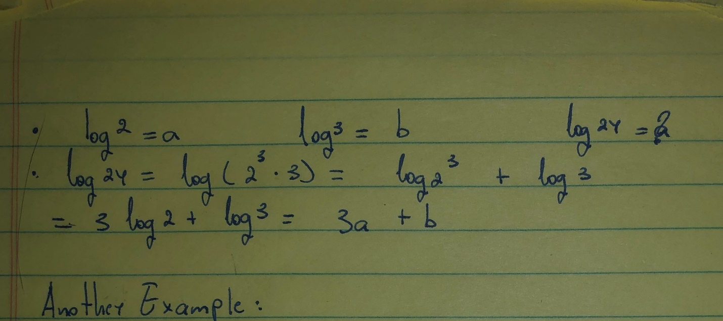

As said previously, the problems above include a mutation of the problem. In the first example, this includes factorizing 24. Then, using the properties of logarithms, we can further unfold the found factorization into what is reminiscent of the given information. Our last step is to substitute the given information into what we have just found, thus finding our answer.

Following is the second example:
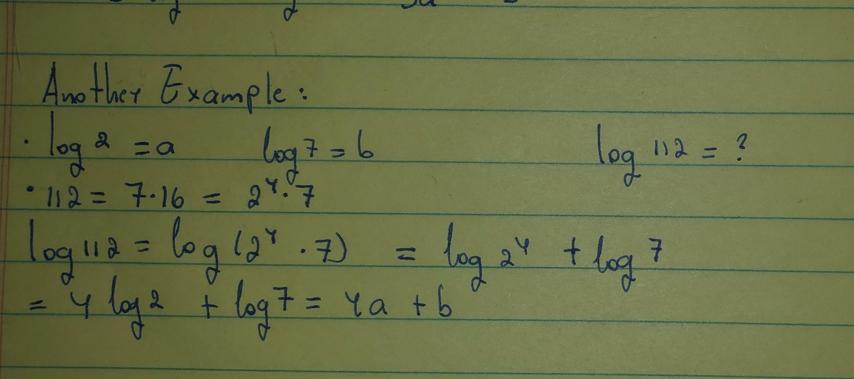
This is slightly more difficult as 112 is a larger number than 24, however, the algorithm for this problem is identical to the previous. Firstly, we must factorize 112; then use the properties of logarithms; and finally substitute the given information appropriately.
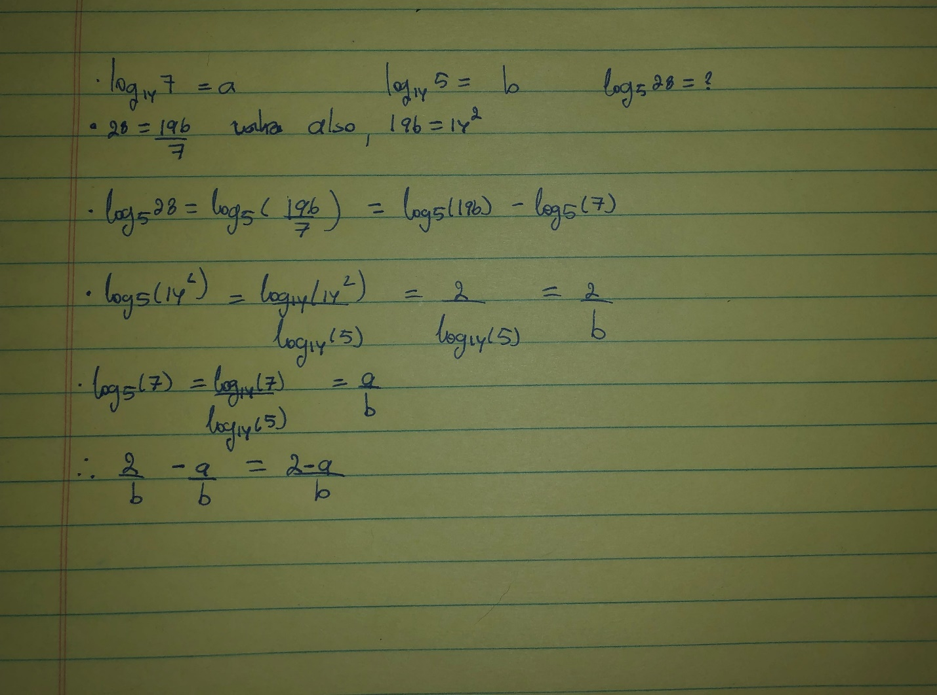

The last problem(shown above) is slightly more difficult, as there is more guesswork involved. Again, we need to look at the information given and transform the problem into it. This problem also involves a change of base, as the unknown logarithm is base 5, and the known logarithms are base 14. When doing the guesswork while substituting 28 into $\frac{196}{7}$, I wanted to ensure that (a) the fraction is equivalent and (b) it incorporates both 14 and 7. In this case 196 = 28(7), which is also 14²(7). This substitution is a matter of guesswork and does not have a specific method. After finding this information, I expanded my single logarithm into two using the properties of logarithms. Here is where a change of logarithmic base comes into play. Using the change of base formula, we can change the base 5 logarithm into a base 14 logarithm, and instantly, the given information pops out. Lastly, all that is required is to substitute the found information into a previous line, and organize the answer.

